Paterson Timber Limited
140 Elliot Street, Glasgow
0141 221 6445
sales@paterson-timber.com
Instagram: @patersontimber
www.paterson-timber.com

STOCK SHEET – March 2024

Hardwoods
 | 1” | 1 ¼ “ | 1 ½” | 2” | 2 ½” | 3” | 4”
 | 25.4mm | 31.8mm | 38.1mm | 50.8mm | 63.5mm | 76.2mm | 101.6mm
DARK RED MAJAU
DARK RED MERANTI
AMERICAN WHITE ASH
AMERICAN WHITE OAK
AMERICAN HARD WHITE MAPLE
AMERICAN RED CHERRY
PREMIUM GRADE WALNUT
AMERICAN RED OAK
AMERICAN TULIPWOOD
PRIME GRADE EUROPEAN OAK
WANEY EDGE, PIPPY OAK
EUROPEAN STEAMED BEECH CND
EUCALYPTUS RED GRANDIS
AFRICAN SAPELE
AFRICAN SIPO / UTILE
AFRICAN IROKO
AFRICAN FRAMIRE (IDIGBO)
AFRICAN AGBA

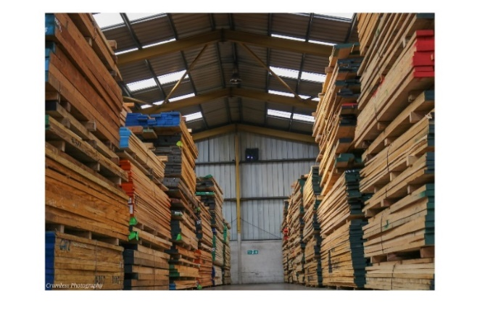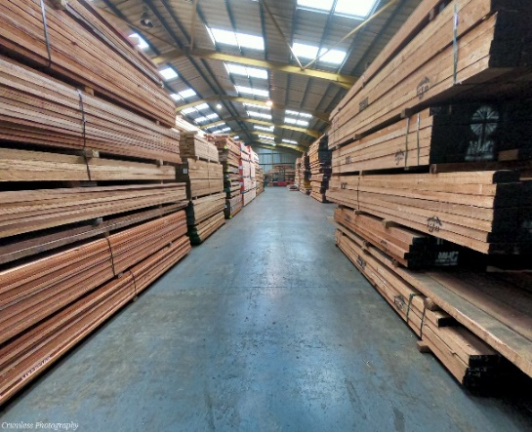
North American Stock Malaysian and African Stock

Softwoods
NORTH AMERICAN SOFTWOOD SET SIZES
 | 150 | 280 | 300
CLEAR DOUGLAS FIR
38 x
SOUTHERN YELLOW PINE
25 x
38 x
50 x
CLEAR WESTERN RED CEDAR
25 x

UNSORTED FINNISH RED PINE SAWN & BOARDS (PEFC Certified Stock)
 | 100 | 125 | 150 | 175 | 200 | 225
19 (Boards) x
25 (Boards) x
38 (4ex) x
50 x
63 x
75 x
100 x

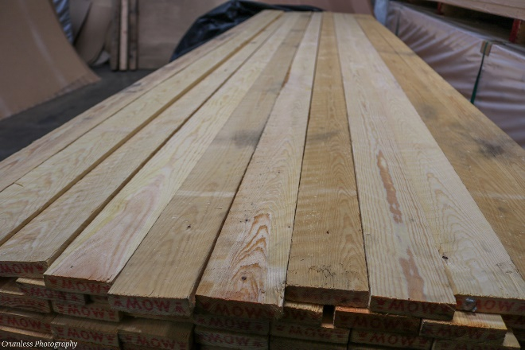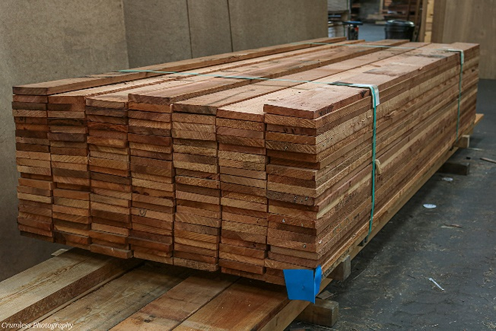
Finnish Red Pine Boards Western Red Cedar

SAWFALLING WHITE PINE STAIRWOOD SAWN (Certified Stock)
38 x 275

UNSORTED SIBERIAN LARCH KILN DRIED (Certified Stock)
Due to current sanctions once we run out of material we won’t be able to bring any more in
50 x 200, 4.0 metre lengths
Modified Products

Modified products enhance the properties of a timber with low durability outdoors to give it a greater lifetime and improve durability, similar to a slow grown hardwood.
A1 Grade Accoya | A2 Grade Accoya | Durawood Thermowood
25 x 200, 4.8 metres | 50 x 200, 4.8 metres | 26 x 360, 5.05
38 x 150, 4.8 metres | 63 x 200, 4.2 metres
50 x 100, 2.4 metres | 75 x 200, 4.2 metres
50 x 150, 4.8 metres
63 x 125, 2.4 metres
63 x 150, 4.8 / 2.4 metres
75 x 150, 4.8 metres

Veneered Products

DECORATIVE VENEERED MDF BOARDS (Other Veneered Boards can be manufactured to order)

V1S – Veneered 1 Side V2S – Veneered 2 Sides
3050 x 1220 = 10 x 4 2440 x 1220 = 8 x 4

 | 3050 x 1220 | 2440 x 1220
 | 19mm V2S A/B | 19mm V2S A/B | 13mm V2S A/B | 4mm V1S + Balancer
American Walnut
White Beech
Steamed Beech
Crown Cut White Ash
Cherry
Maple
Pine
Quarter Cut White Oak
Crown Cut White Oak
Baltic Pine (A/A)
Quarter Cut Sapele
Crown Cut Sapele
We also carry Crown Cut Oak in the following:
 | 2440 x 1220
 | 26mm V2S A/B | 10mm V2S A/B | 6mm V2S A/B
Crown Cut White Oak

Pre-Glued Real Wood Edging Tape
22mm x 50 metre rolls only available: Ash, Cherry, Maple, Pine, Beech, Steamed Beech, Sapele, Douglas Fir, Oak, Walnut
50mm x 50 metre rolls available: Walnut, Oak

Decoflex Flexible Veneer
0.6mm x 3050mm x 1240mm available: Crown Cut Oak, Crown Cut Walnut, Crown Cut Ash

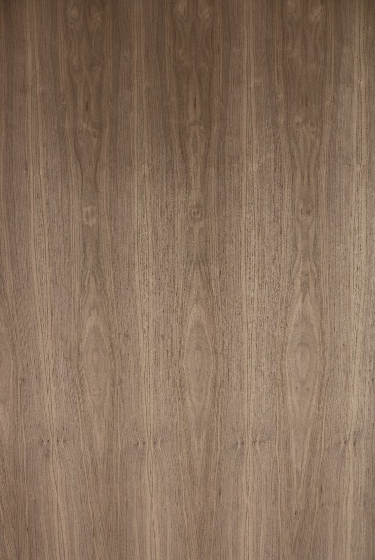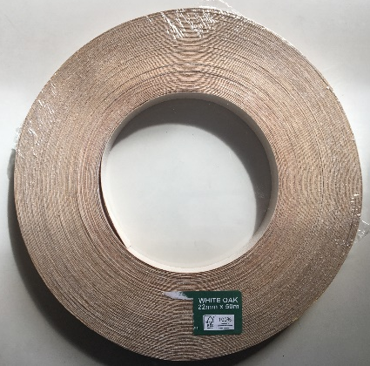
Veneered Walnut MDF White Oak Edging tape

Laminated Products

Clear Faced (C/F) – Solid 10mm piece on top of each face
2 Part – Made up 2 sections with a mid-joint, colour matched for appearance
Edge glued (E/G) – Different sections glued along the edge to give greater dimension size
Finger Jointed (F/J) - complementary, interlocking sections put together to give greater stability after being glued. The finished look resembles ‘interlocking’ fingers

Our Laminated Products are detailed as ‘Thickness x Face’

72x96 96x72
FACE (F/J) FACE (F/J)

Laminated

Laminated Window Sections
Laminated Red Pine KD Certified – available in 6.0m lengths
Finger Jointed – Available in 6.0m lengths
63 x 63, 63 x 75, 63 x 86, 63 x 96, 63 x 120, 72 x 60, 72 x 72, 72 x 86, 72 x 96, 72 x 145(J), 86 x 72, 96 x 63, 96 x 75, 96 x 96
Laminated Eucalyptus Grandis KD Certified
Finger Jointed – Available in 5.9m – 6.0m lengths
63 x 63, 63 x 86, 63 x 95, 63 x 200(J), 72 x 75, 72 x 86, 84 x 75, 96 x 63, 96 x 75, 96 x 96, 126 x 63
Laminated Sapele KD –
Finger Jointed - Available in 5.9 metre lengths
120 x 48
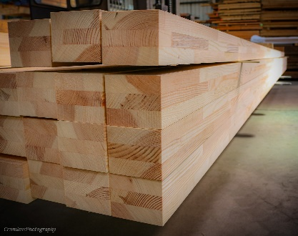 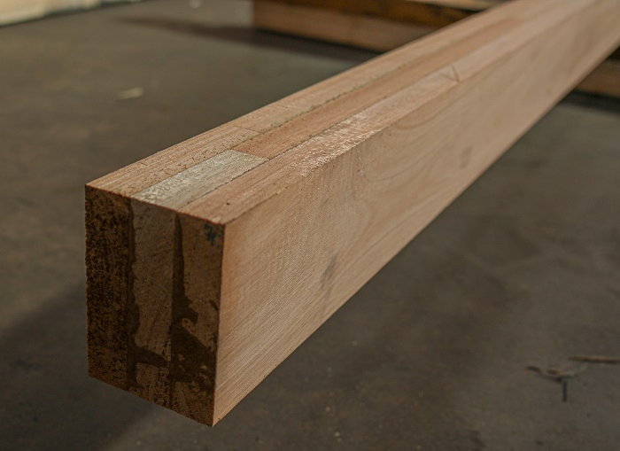 F/J Laminated Red Pine KD F/J Laminated Eucalyptus Grandis KD

Laminated Stair Sections

Laminated European Oak KD Certified
Finger Jointed & Edge Glued
STRINGERS - 275 x 32 – Available in 4.8 metre lengths
Clear Faced
NEWELS - 90 x 90 – Available in 3.0m, 2.1m, 1.8m, 1.7m, 1.5m lengths
HANDRAIL - 63 x 63 – Available in 4.8m
A /B Grade (Supreme Colour Match) – A face has up to 3 joints, B face has 3 joints or more/
B / B – more than 3 joints on each face
BALUSTER/ SPINDLE SQUARES (Jointed) - 41 x 41 – Available in 0.915m, 1.1m lengths
Edge Glue only
Treads 275 x 25, 275 x 32 – Available in 1.0m lengths
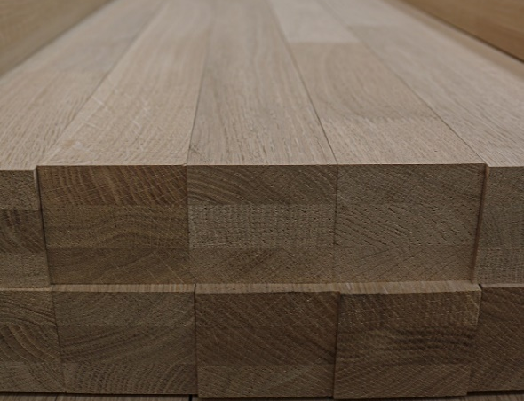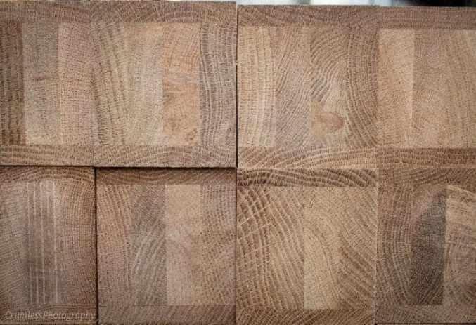

European Oak Handrails Clear Faced Laminated European Oak Newels

Laminated American White Oak
Edge Laminated and Colour Matched – Available in lengths ranging from 2.0m – 5.0m
2 piece – 275 x 32

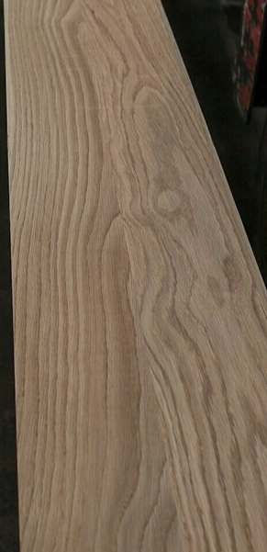

Laminated Red Pine
Edge Glued and Shrink Wrapped – Has Sound Knots
STRINGERS - 270 x 33 (A/B Grade) – Available in 4.45m, 4.75m and 5.05m lengths
STRINGERS - 270 x 33 Bullnosed – Available in 3.0 metre lengths

Finger Jointed, Edge Glued – Knot Free
STRINGERS - 275 x 33 – Available in 6.0m lengths
STRINGERS - 288 x 36 – Available in 6.0m lengths

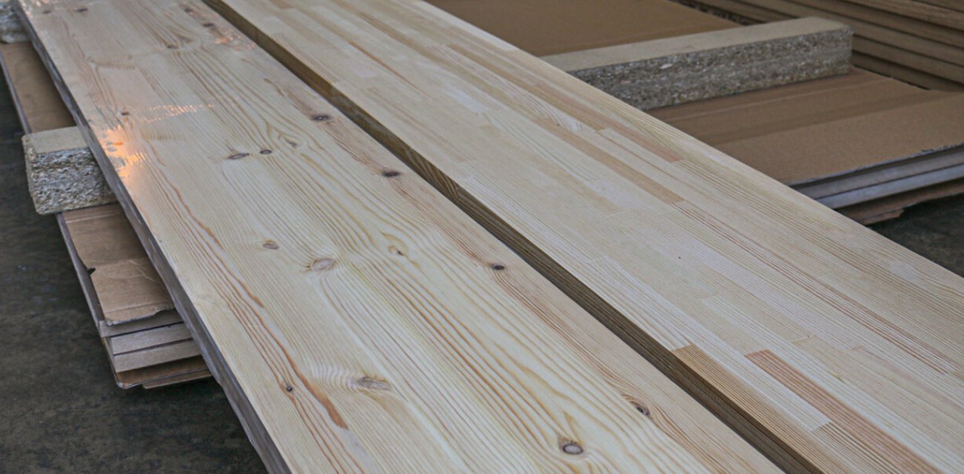

Left: Shrink Wrapped Red Pine Stringers with sound knots compared to Right: Finger Jointed Red Pine Stringers (knot free)
Laminated Door Sections

Laminated European Oak KD
Clear Faced – Available in 2.5m, 2.1m, 1.1m, 0.9m lengths
48 x 105, 48 x 120, 60 x 105, 60 x 120

Laminated Red Pine KD Certified
Finger Jointed – Available in 6.0m lengths
120 x 48, 192 x 48, 192 x 60, 144 x 60, 120 x 60
Clear Faced Available – Available in 2.5m, 2.1m, 1.1m, 0.9m
48 x 105, 48 x 120, 60 x 105, 60 x 120

Dark Red Meranti KD Certified
Clear Faced Laminated - Available in 2.5m, 2.1m
48 x 120, 60 x 120

Laminated Eucalyptus Grandis KD Certified
Finger Jointed - Available in long lengths
63 x 200, 125 x 63, 63 x 120
Clear Faced Laminated
63 x 105, 63 x 120, 63 x 125
C/F Laminated European Oak C/F Laminated Dark Red Meranti
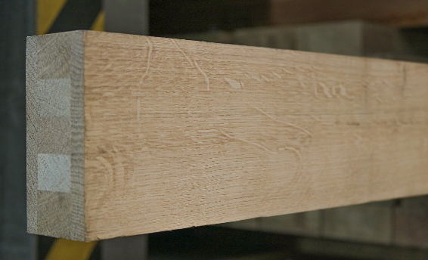 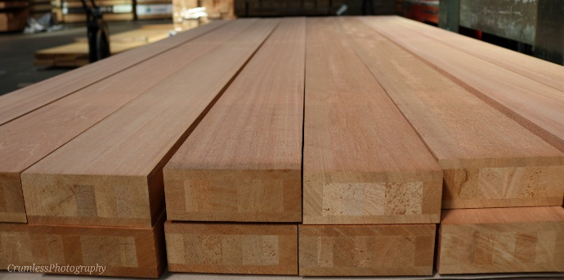
C/F Laminated Red Pine
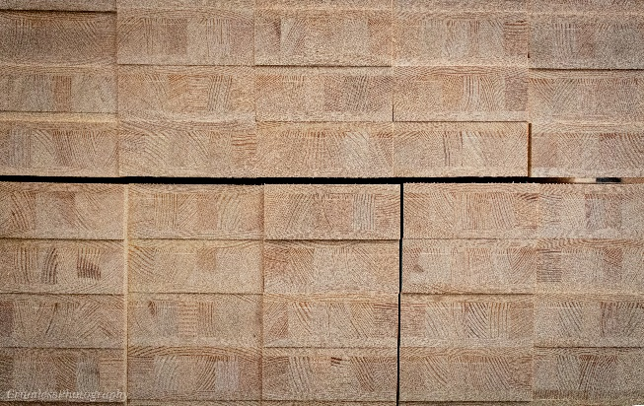

Other items may be available upon request

